16.54: The steel rod has standing waves much like a pipe open at both ends, as shown in Figure (16.18). An integral number of half wavelengths must fit on the rod, that is, 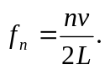
a) The ends of the rod are antinodes because the ends of the rod are free to ocsillate.

b) The fundamental can be produced when the rod is held at the middle because a node is located there.
c) 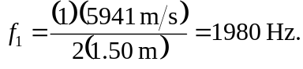
d) The next harmonic is 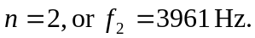We would need to hold the rod at an n = 2 node, which is located at 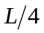 from either end, or at 0.375 m from either end.

